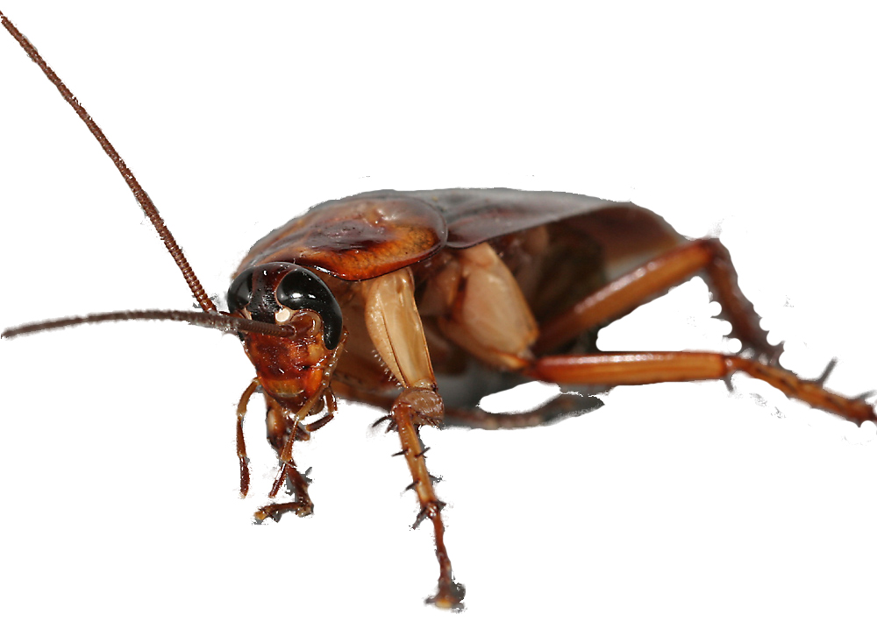
Install these to prevent pests from
crawling in:
Door sweeps along the entire length of the bottom of the door
Screens on exterior doors, windows, and air vents
Escutcheon plates secured where appropriate or seal gaps around pipes and lines
Silicone caulk, sealing edges of fixtures in bathrooms and kitchens
Low sodium (yellow) lights on the exterior of buildings
Dumpsters on a cement or asphalt pad away from the building. Keep covered with drain holes plugged and empty regularly
Fascia and soffits that are free of
holes

Working together towards pest-free housing.
- Residents: keep pests from getting food, water, and shelter.
- Resident Services: help residents learn how to do their part and get support.
- Maintenance: fixes holes that let pests in.
- Pest Control: monitors for pests and applies pesticides.
- Management: makes sure everyone is doing his or her part to keep our building pest-free.
Brought to you by the
Development Name Management Office and
The Regional IPM Centers
To place a work order, call:
000-0000

What does poor sanitation look like?

To live happily pests need
- food,
- water, and
- a place to hide.
Maintenance must complete repairs in a way that reduces access to these things.

Integrated Pest Management (IPM) at PHA
Talking about pest control
No one wants to live or work with pests.
Insert Development-Specific Photo
Insert Development-Specific Photo
TEMPLATE: Rev. 12/11
Download at www.stoppests.org
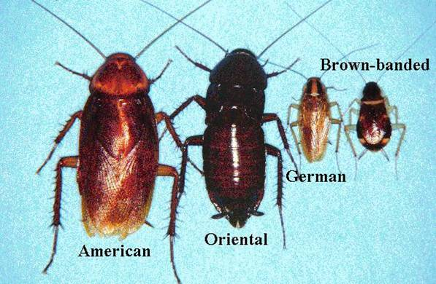
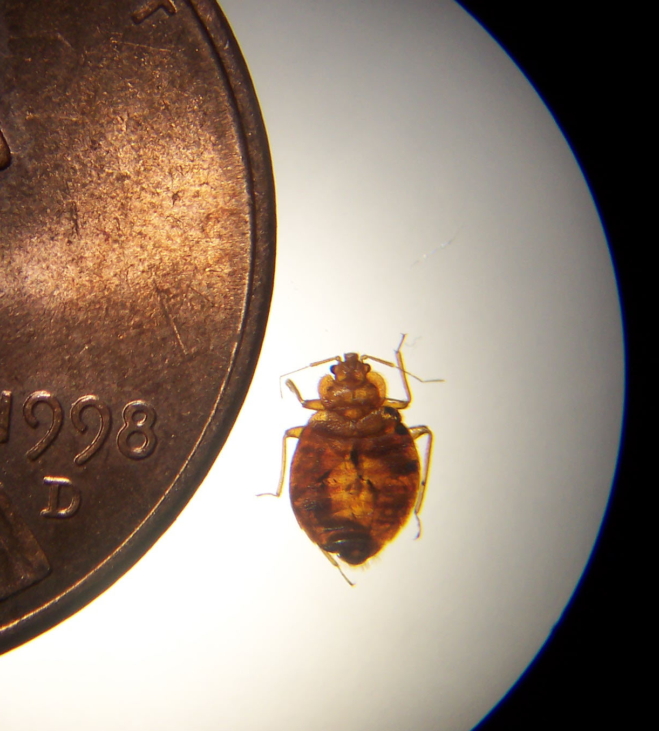
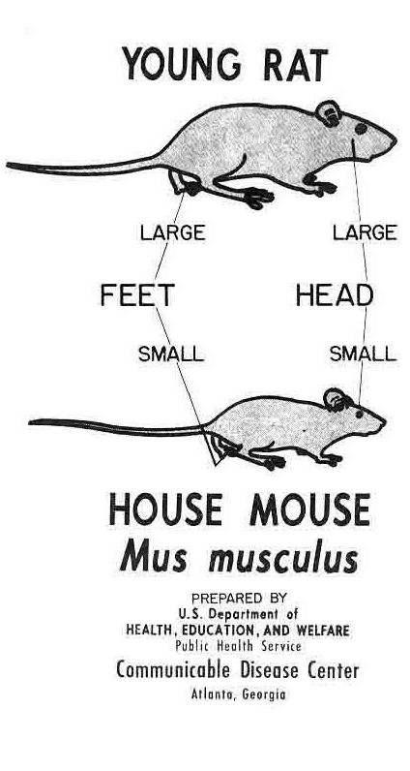

Avoid the word “you.” Instead, speak in terms of the pest.
Lead the resident to figure out what he or she needs to do.
For example,
DON’T SAY: “You need to clean up your dishes.”
DO SAY: “Cockroaches get food and water from our dishes at night. Where would a cockroach find food here? How could we take that food away?”

Be positive—no infestation is too great for IPM if everyone works together!
Ask questions—Find out about the residents’ concerns, limitations, and what they are doing on their own for pest control.
Build trust by relating to the resident and following up on promises.
Show the resident how to
Use a vacuum
Lift up the stovetop for cleaning
Inspect for bed bugs
Call in a work order
Cockroaches are health hazards!
Even the dead ones can make asthma worse in sensitive people and cause asthma in preschool-aged children!

How to talk about pests
Bed Bug

Cockroaches

What a resident can do to kill pests:
- Trap them and throw them away.
- Vacuum them up (seal the bag in a plastic bag and put it in the trash).
- Do laundry—a hot clothes dryer kills bed bugs.
- Focus efforts on housekeeping.

Call 000-0000 to get a professional to apply pesticides.
Never use “bug bombs” or “foggers.”

Avoid the word “you.” Instead, speak in terms of the pest.
Lead the resident to figure out what he or she needs to do.
For example,
DON’T SAY: “You need to clean up your dishes.”
DO SAY: “Cockroaches get food and water from our dishes at night. Where would a cockroach find food here? How could we take that food away?”

= one inch

